CHRIST (Deemed to be University)
Department of Computer Science
MSc AIML
Course: MAI511-1 - Advanced Database Technologies
Exercise No: LAB Exercise – 7
Date of assignment: 12-08-2026
Date of submission: 15-08-2026
Exercise:
Demonstration of CRUD operations and Aggregate functions in MongoDB
With respect to your chosen business domain, create a MongoDB database and design
the required collections. Each collection should contain a minimum of 5 documents.

Perform the following operations:
- Create Operations
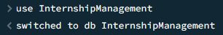

• Use insertOne() and insertMany() to add documents to each collection.

insertOne():
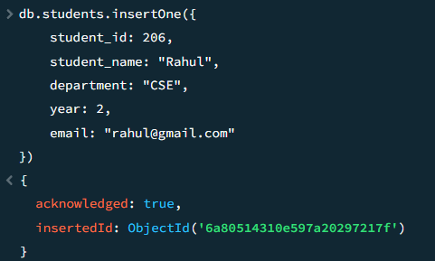
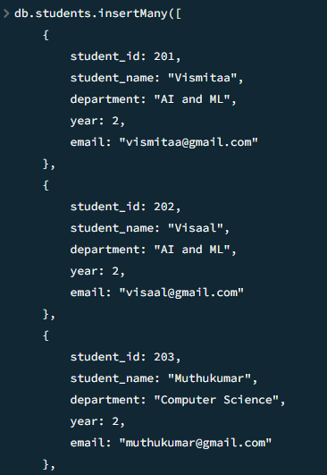
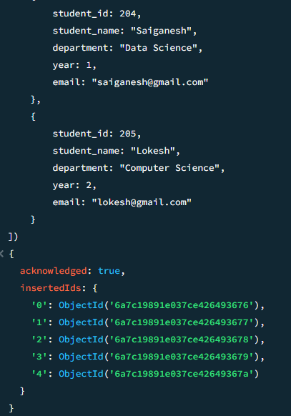

2. Read Operations
• Use find(), findOne(), and appropriate filters to retrieve documents.
Find():

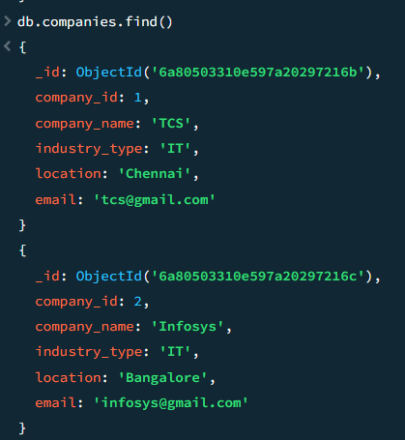
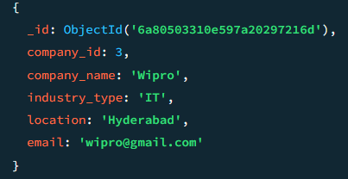
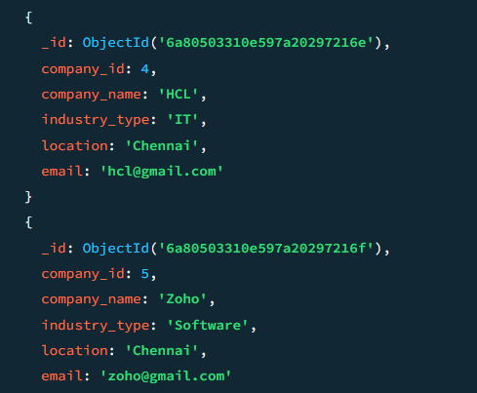

Find one():

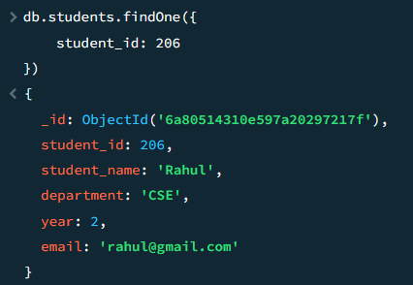
3. Apply logical operators:
• $and, $or, $not, $nor
$and:
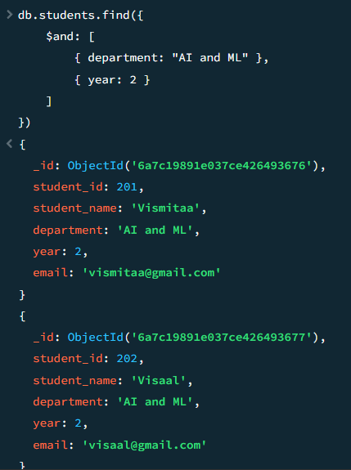
$or:
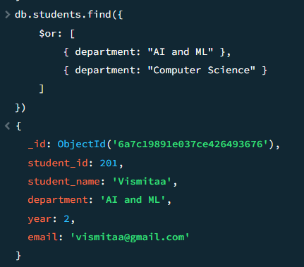
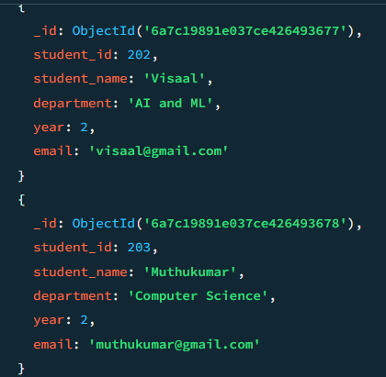
$not:
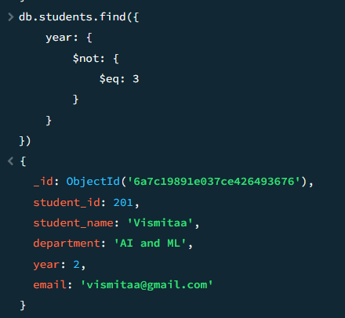
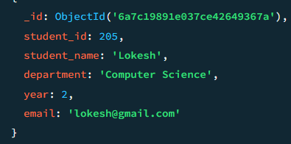
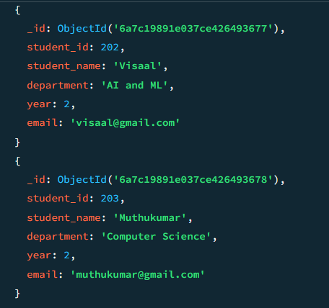
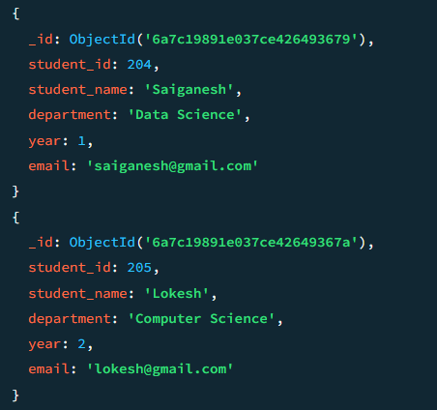
$nor:
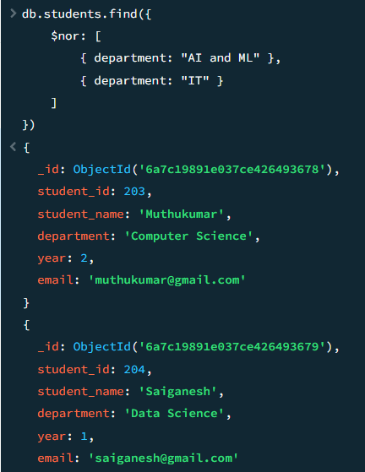
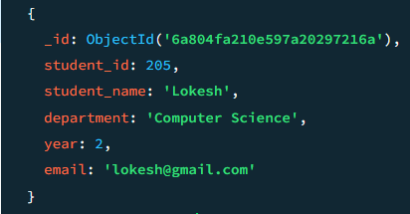

4. Apply relational operators:
• $gt, $lt, $eq, $ne, $gte, $lte, $in, $nin
$gt:
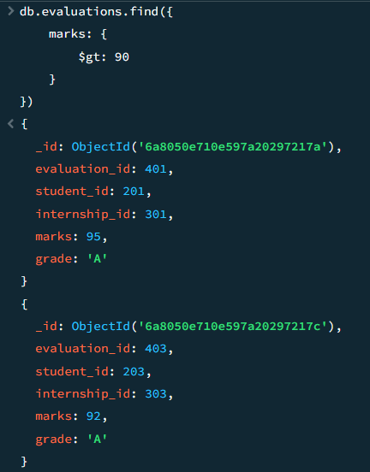
$lt:
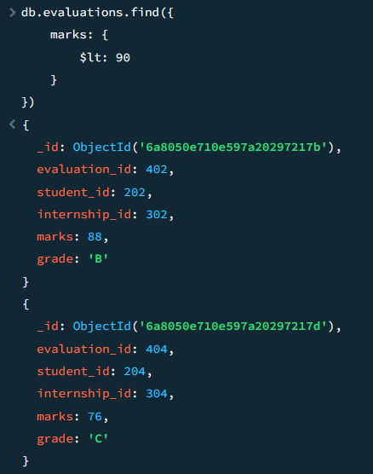
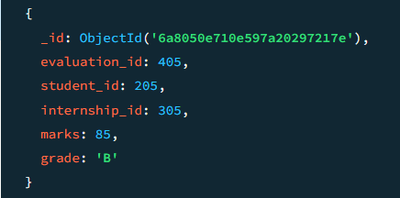
$eq:
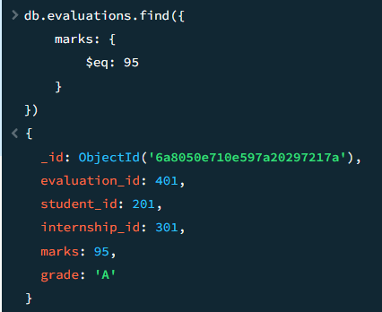
$ne:
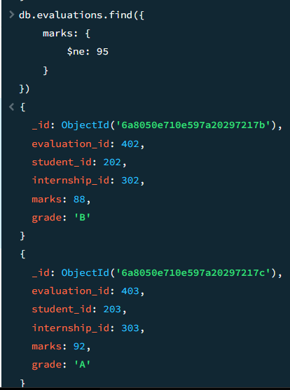
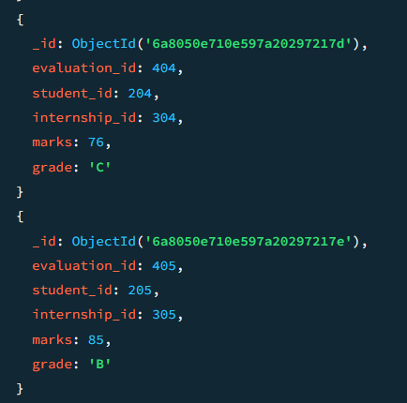
$gte:
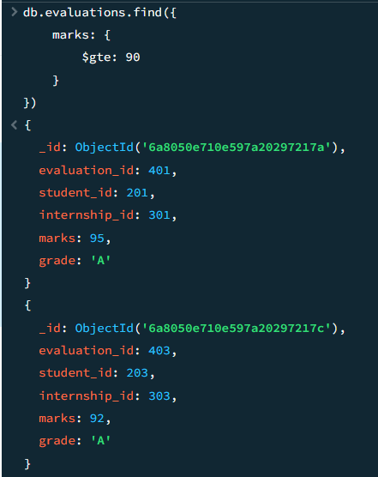
$lte:
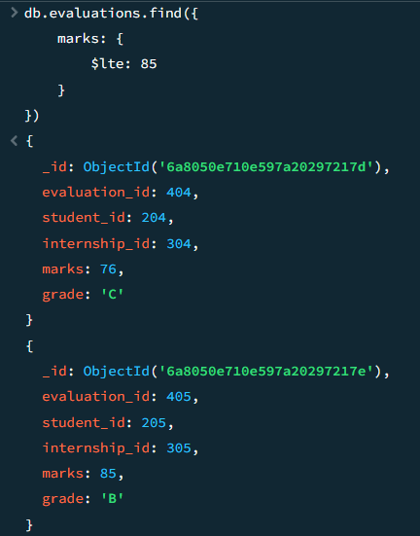
$in
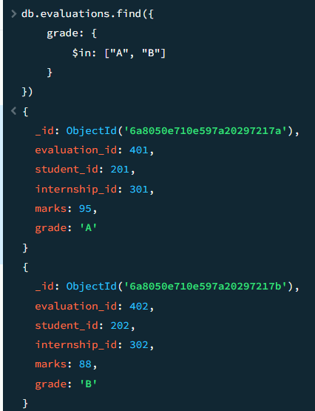
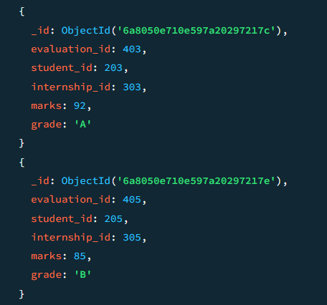
$nin
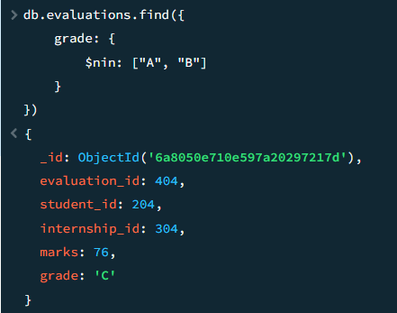
5. Update Operations
• Use updateOne() and updateMany() to modify fields or nested values in
the documents.
updateOne():
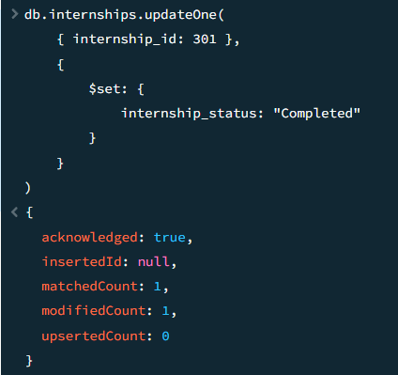
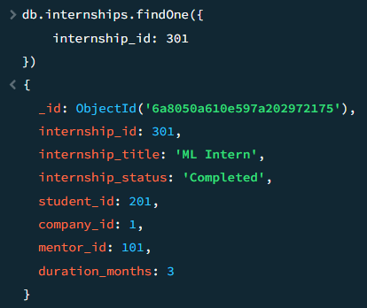
updateMany():
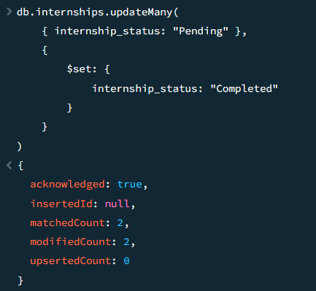
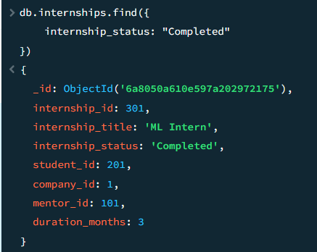
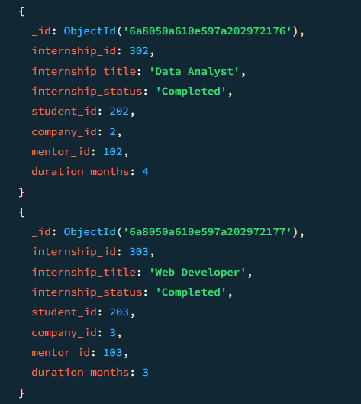
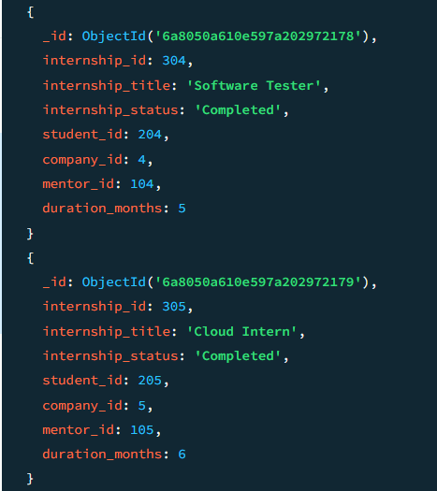
6. Delete Operations
• Use deleteOne() and deleteMany() to remove specific or multiple
documents.
deleteOne():
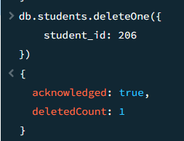
deleteMany():
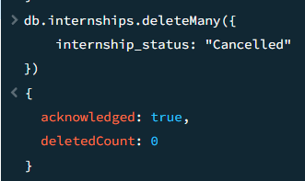
7. Aggregation Operations
• Use aggregation functions and stages wherever applicable: $match,
$group, $sum, $avg, $count, $project, $sort, $unwind, $lookup, etc.
$match
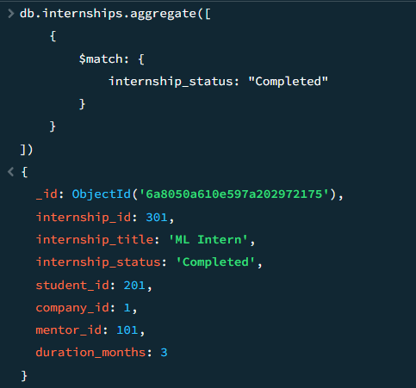
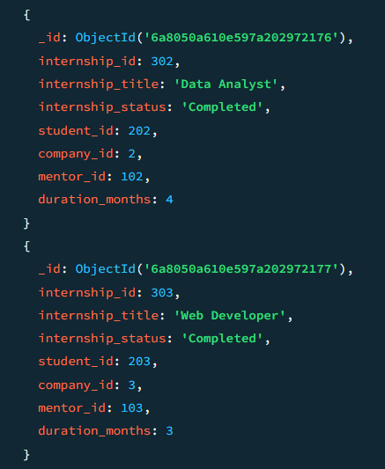
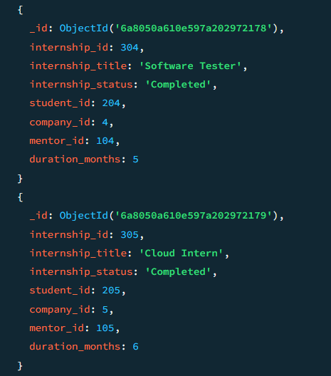
$sum
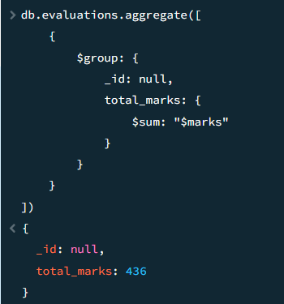
$avg
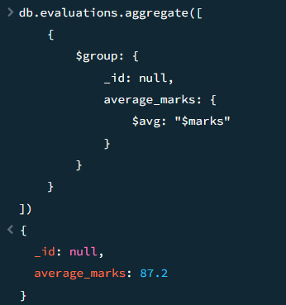
$count
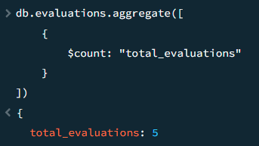
$project
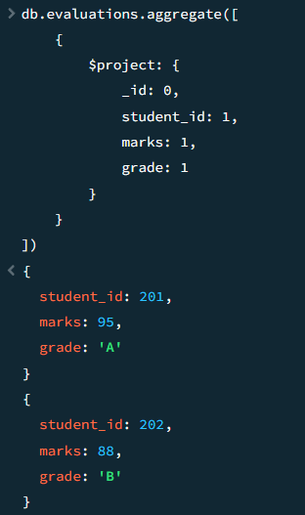
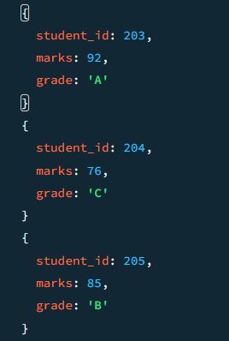
$sort
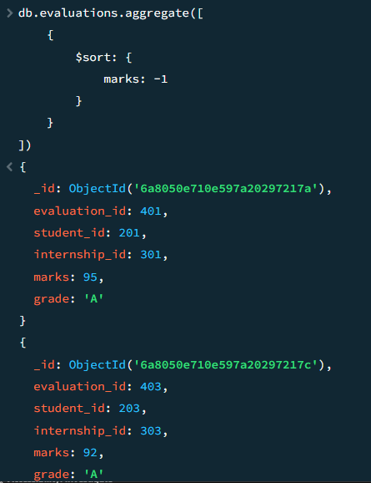
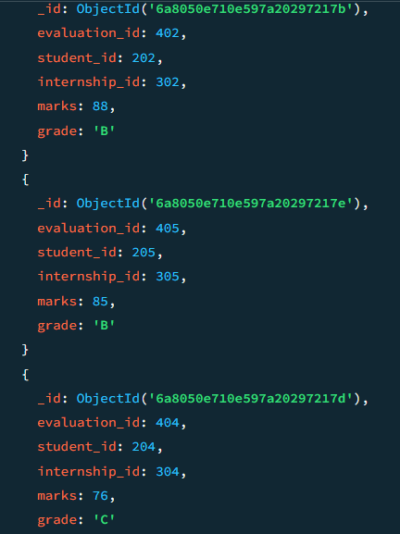

$unwind
$lookup
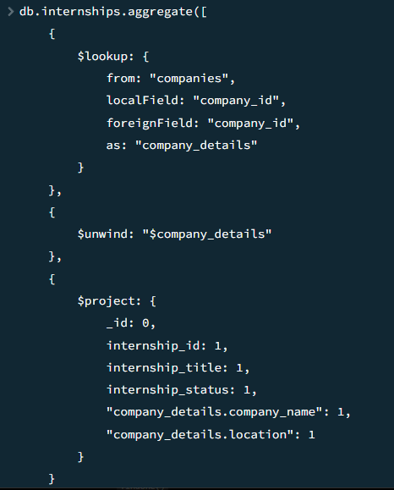
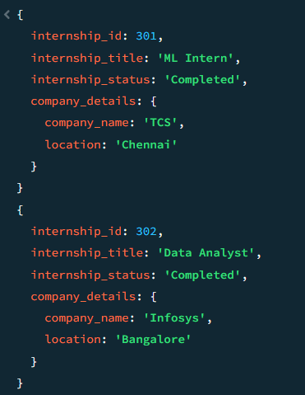
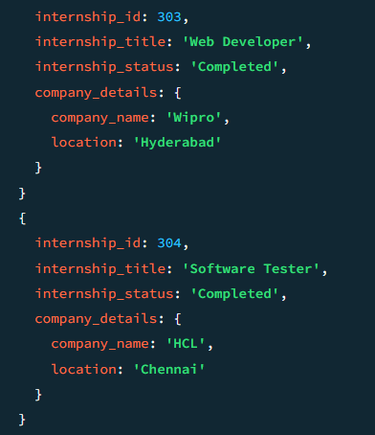
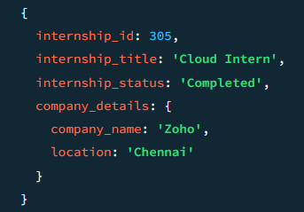

Evaluation Scheme: (Total 10 Marks)
Correctness and Demonstration (5 marks)
Concept Clarity (Viva) (3 marks)
Initiative & Effort (self-learning) (2 marks)

General Instruction:
1. Create a Word document and paste all the answers. The file name should be your
register number followed by lab No. Example: 2647101_Lab7
2. Upload the answer document in Google Classroom on or before the deadline
mentioned.

